**Use Scenarios**

**Scenario: Finding Overdose death numbers and information from New York**

1. Go to website.

2. Click on the state drop down menu.

3. Scroll until “New York” is found.

4. Click “New York”

**Scenario: See how many people overdosed on a certain drug in New Jersey**

1. Go to website.

2. Click on the State drop down menu.

3. Scroll until “New Jersey” is found.

4. Click “New Jersey”.

5. Click on the “Drug” drop down menu.

6. Click on the drug that you want to the see the results for.

**Storyboard**

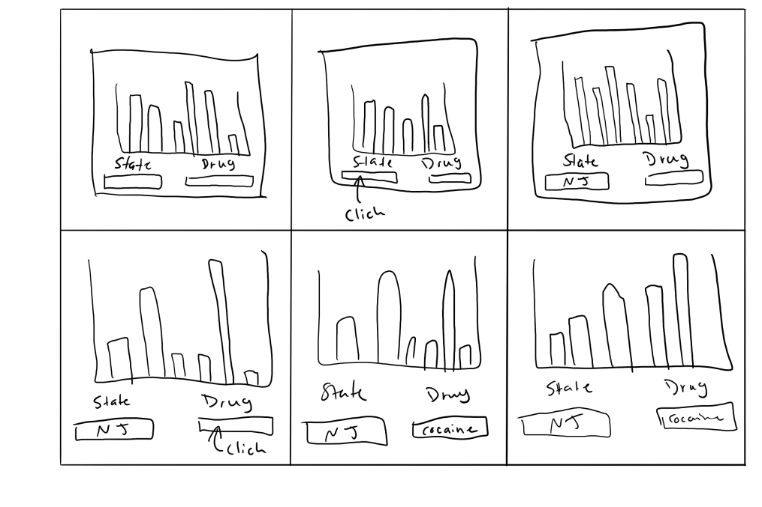

**Wireframe**

Wireframe


**Logo**

**Color Scheme**

**Font**

